**Load Assessment & Graphic Exploration**

Plotting time series values for the selected building (private apartment dataset) allow to identify different patterns such as trends and seasonality. Moreover, it enables many features of the data. In particular, we can highlight the changes over time and recognize unusual observations.

In this section we have performed the load assessment process in two different periods: full year and winter term to perceive if there are any hidden patterns.

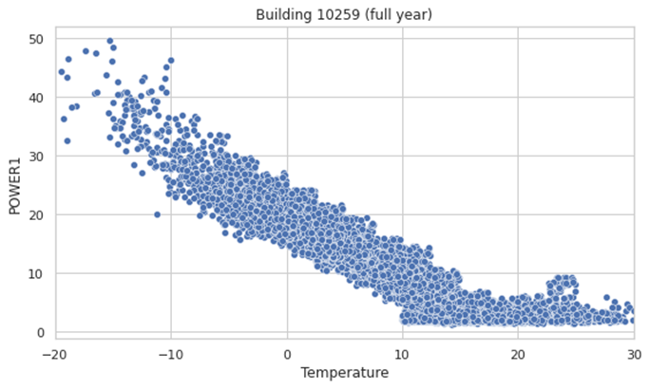

**Figure 1. Hourly heat load vs outdoor temperature in building 10259 (full year)**

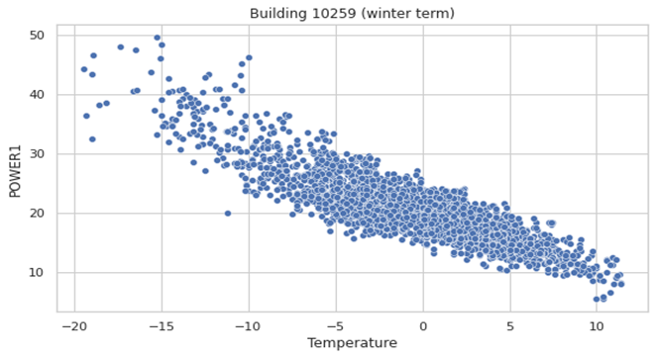

**Figure 2. Hourly heat load vs outdoor temperature in building 10259 (winter term)**

The decrease in the heat load (fig 1, fig 2 above) was followed by a growth in terms of outdoor temperature. This increase of temperature indicates the strong correlation between weather variable and heating demand. Part of the heating demand is dedicated to domestic hot water consumption (DHW) which is illustrated by the roughly horizontal profile against the weather data as shown in fig 1. Indeed, the hot water consumption shows little to no dependence on weather variable and seasonal variation.

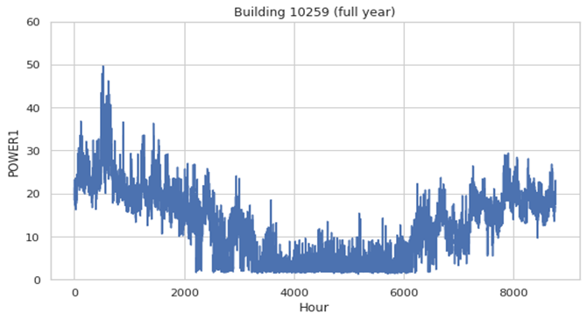

**Figure 3. Hourly heat load in building 10259**

The decrease in heat load (fig 3 above) does not decline totally in the summer period (between 4000 hours to 6000 hours). One reason of this pattern is that the total heat consumption does not include only the space heating but also includes the hot water production which is known to have no dependence on climatic variables, it rather depends on the random nature of specific user behavior.

***Annual Seasonality***

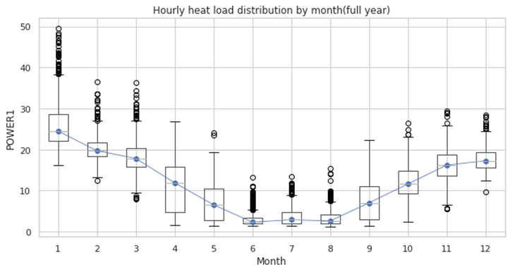

**Figure 4. Hourly heat load distribution by month (full year)**

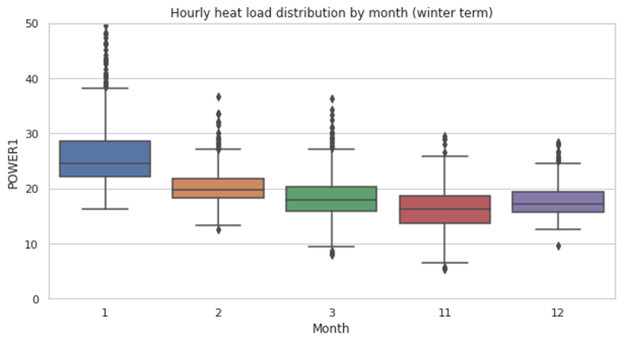

**Figure 5. Hourly heat load distribution by month (winter term)**

In fig 4 and fig 5 above, the graphs represent the hourly heat load distribution by month. For the full year (fig 4), a sharp decrease is detected in median heat load in which the line continues to fall to reach the lowest level from July to August and rise again in the fall term (October to November). From this observation we can confirm that we have a clear annual seasonality.

During winter term (fig 5 above), January represents the highest month in term of energy consumption unlike November which has the lowest hourly heat load comparing to other months.

***Weekly Seasonality***

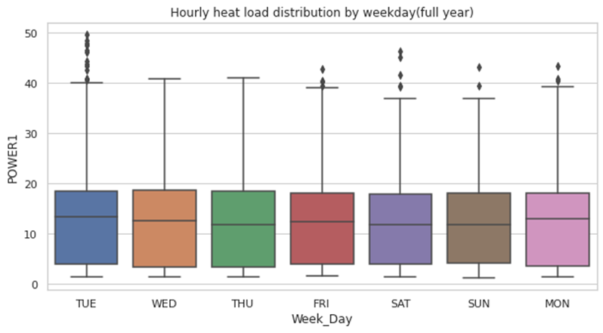

**Figure 6. Hourly heat load distribution by weekday (full year)**

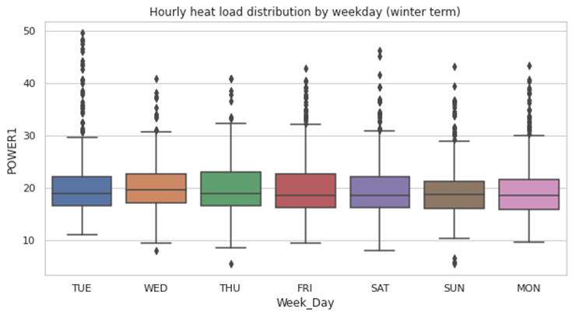

**Figure 7. Hourly heat load distribution by weekday (winter term)**

Apart from the slight increase on Thursday as can be seen in fig 20 above. The hourly heat load on the other days remains stable with no significant changes in the median heat load along the weekday for both full year and winter term (fig 6 and fig 7)

***Daily Seasonality***

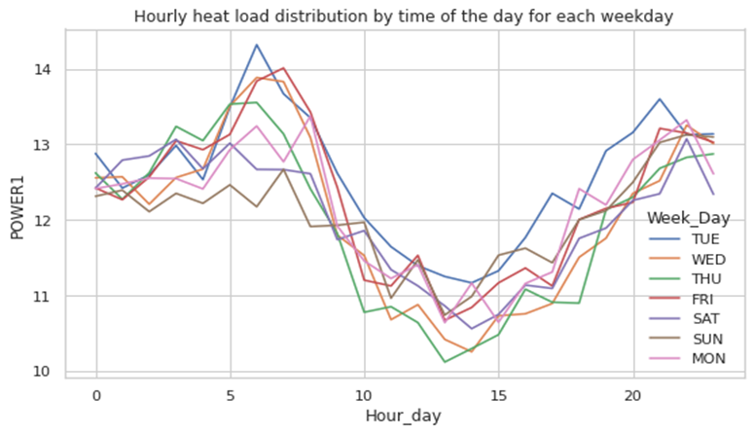

**Figure 8. Hourly heat load distribution by time of the day for each weekday (full year)**

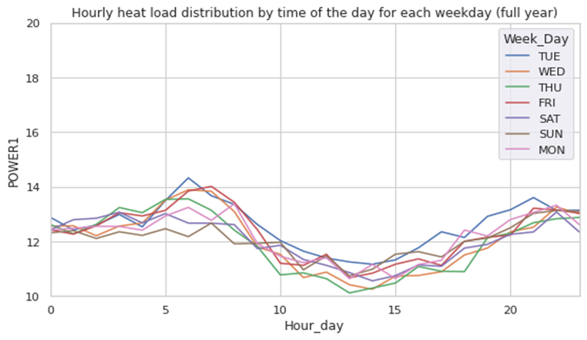

**Figure 9. Hourly heat load distribution by time of the day for each weekday (winter term)**

Fig 8 and fig 9 above represent the hourly heat load distribution by the time of the day for each weekday in full year and winter term respectively. We observe that a sharp decrease of heat load occurred from 5:00 to 15:00. This could be explained by the absence of consumer in the building during these hours, especially from 8:00 to 15:00 which represent the standard working hours. From 5:00 to 8:00, a very accentuated demand peak is spotted. This peak usually came after the night setback where a reduction heat load occurred by the district heating operator. In general, the night setback in district heating is considered as a control strategy to enable the control of the demand peak.

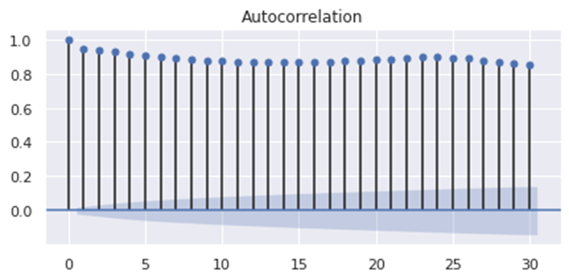

**Figure 10. Autocorrelation plot**

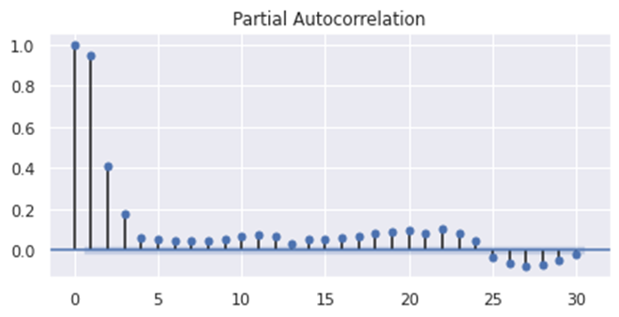

**Figure 11. Partial autocorrelation plot**

Also, a significant autocorrelation as demonstrated in both autocorrelation and partial autocorrelation plots (fig 10 and fig 11 above). The clear association between one hour's heat load demand and previous hour indicates that autoregressive models can work well in our dataset.